
ENDEAVOUR SPORTS HIGH SCHOOL
Cnr Taren Point Rd & The Boulevarde Caringbah NSW 2229
PO Box 226 CARINGBAH NSW 1495
(02) 9524 0615
www.endeavour-h.schools.nsw.edu.au

Parent/Guardian TSP Application for Year 7 2023

Family Name:

Given Name/s:

Current Primary School: ______

Date of Birth: Male/Female: Sibling at ESHS Yes/No
Sibling Name

Name of Parent/Guardian: (Ms/Mrs/Mr)

Email Address: ______________________________________________________________________

Home Address:

__ Post Code: __________

Telephone: Home: _________ Mobile: __ Work:

IMPORTANT
You must submit your application before Friday 25 March 2022

- A $30 non-refundable application fee is required to register your child for a TSP trial. Payments can be made online via the school’s website or link https://endeavoursportshighschool.com/about-endeavour/online-payments/, by telephone or at the school office.

- Trials will be held in the first two weeks of Term 2, 2022.
- TSP is a user pays program with fees paid in advance.
- Acceptance into the TSP program does not guarantee an offer of placement at Endeavour Sports High School. All students must apply for High School by completing the Application to Enrol at a NSW Government School form.
- All Year 6 students will receive an Expression of Interest Form from their primary school and Endeavour Sports High School must be included in Section C as either a 1st or 2nd choice. You will need to complete this form in addition to applying for the Targeted Sports Program.

Parent / Guardian Declaration

- I accept that the Targeted Sports Program is a user pays program with fees paid in advance. I agree that the fees will be paid in full prior to my child commencing the program and for every year my child is in the program.

- I accept that should my child not attend all training sessions and participate with commitment and enthusiasm, demonstrate a sustained and diligent commitment to their studies and maintain a high standard of behaviour and conduct, they may forfeit their place in TSP.

- I accept that should my child no longer be enrolled in TSP, for whatever reason, their enrolment at Endeavour Sports High School will be at the discretion of the Principal. I agree to abide by the decision of the Principal.

- I accept that there is a requirement that all TSP students will be available to represent the school in any competition or carnival the school enters.

- I have attached details of all medical, psychological, social, behavioral or other special circumstances that have required management, intervention or treatment during my child’s school years. This information will remain strictly confidential. Should there be information of a particularly sensitive nature and/or a history of violence, I undertake to frankly and openly discuss this with the Principal.

Parent/Guardian Signature: Date:

Privacy and Personal Information Protection Act 1988

The personal information provided on the Application Form is being obtained for the purpose of processing the student's application for enrolment. It will be used by the Department of Education and Training for general student administration and communication and other matters relating to the education and welfare of students. While the provision of this information is voluntary, if you do not provide all or any of this information it may delay or prevent the processing of this application for enrolment. This information will be stored securely. You may access or correct any personal information provided by contacting the school.

2023 TSP Sport Choices

Students may register to trial for a maximum of two sports. Please select one sport in each column if you are choosing two. Students will be offered the sport of their highest choice should they qualify.
 | 1st CHOICE | 2nd CHOICE
AFL
Athletics
Baseball
Basketball
Cheerleading
Cricket
Dance
Football – Girls
Football – Boys
Gymnastics
Netball
Rugby League/Union – Girls
Rugby League
Rugby Union
Swimming
Tennis

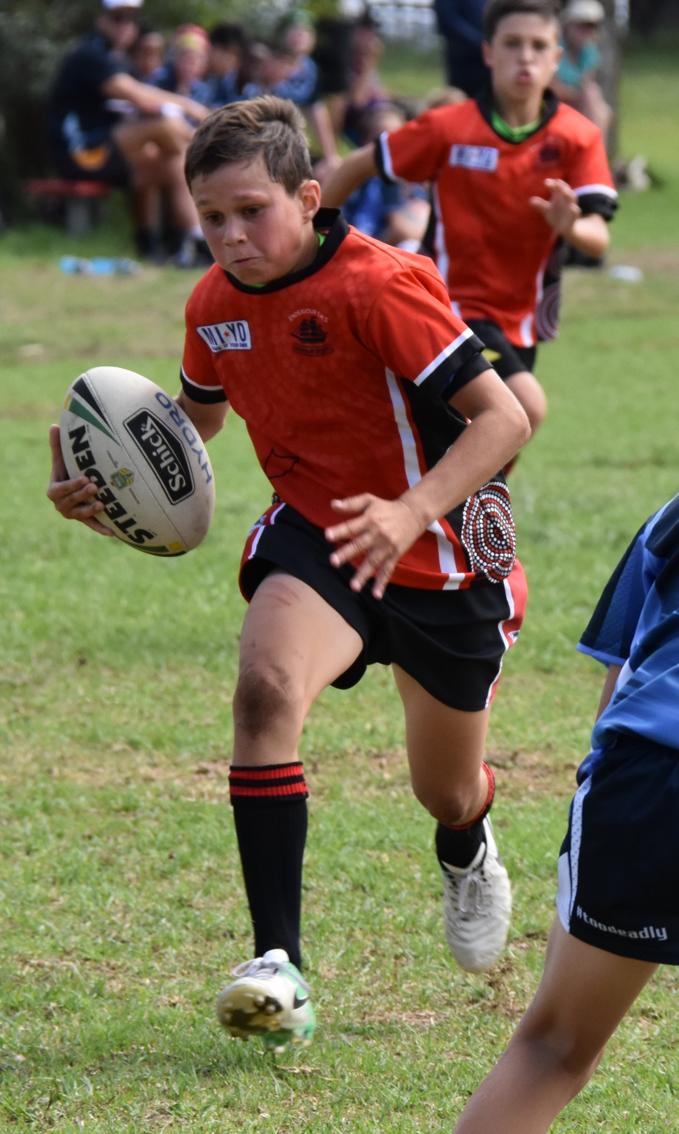
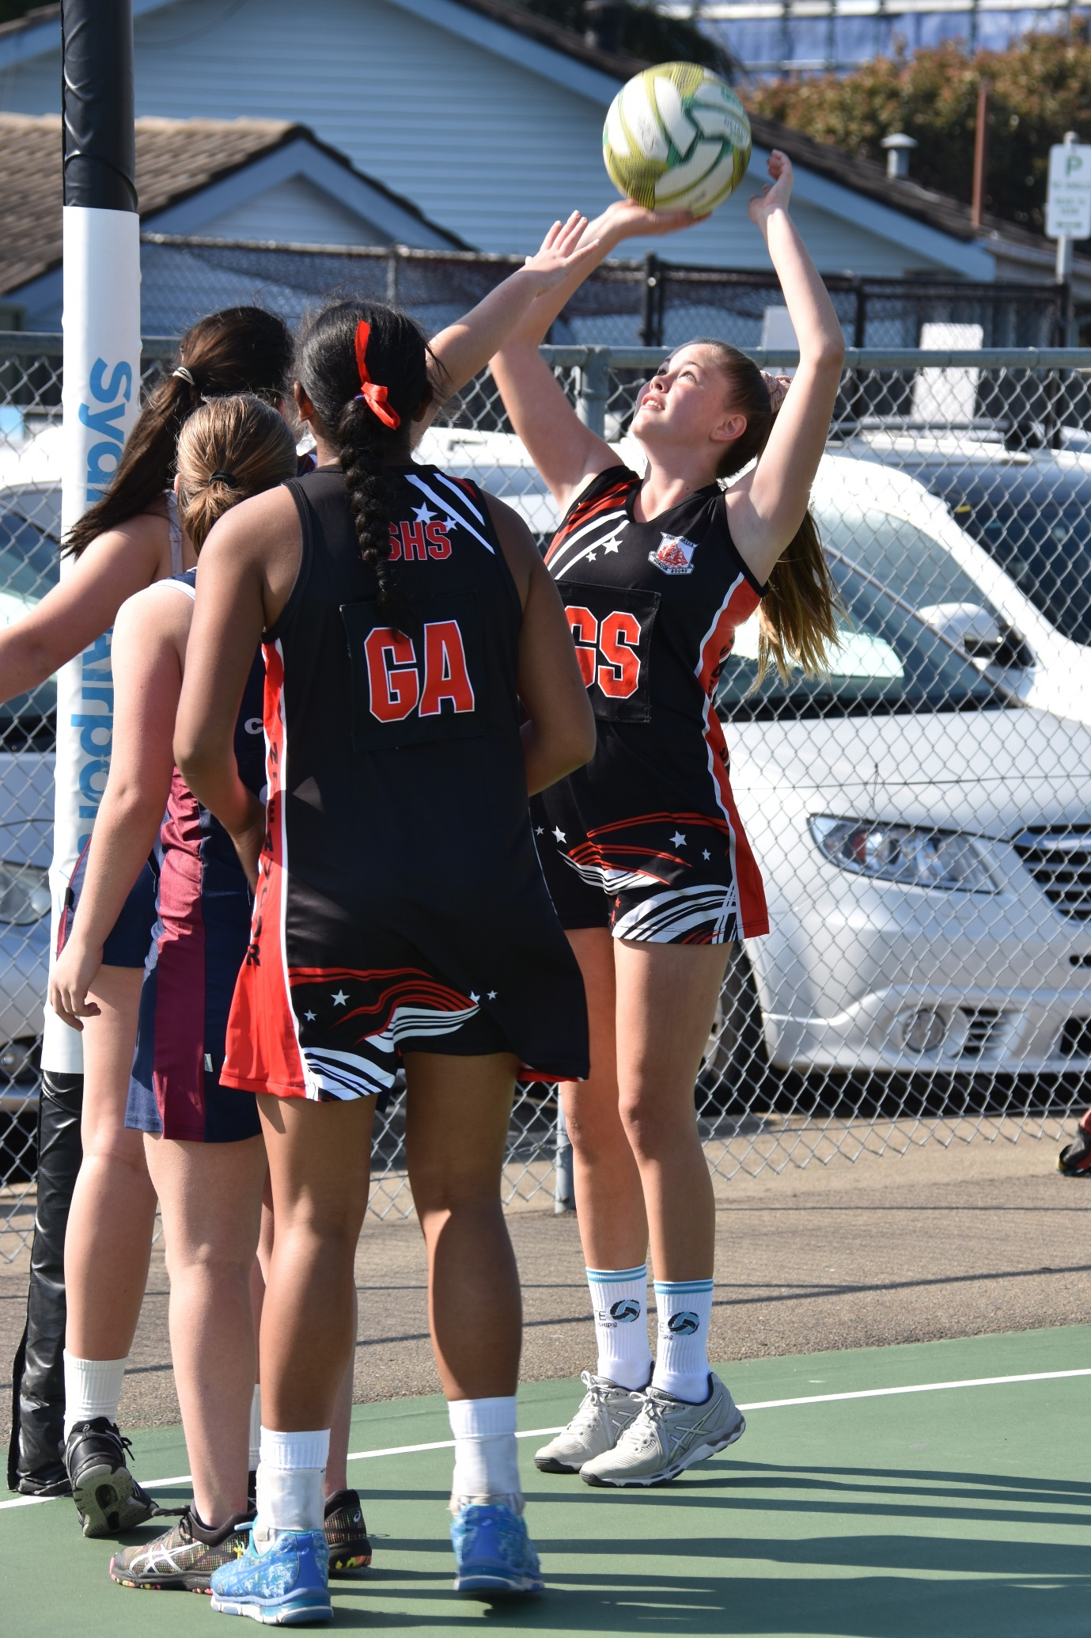
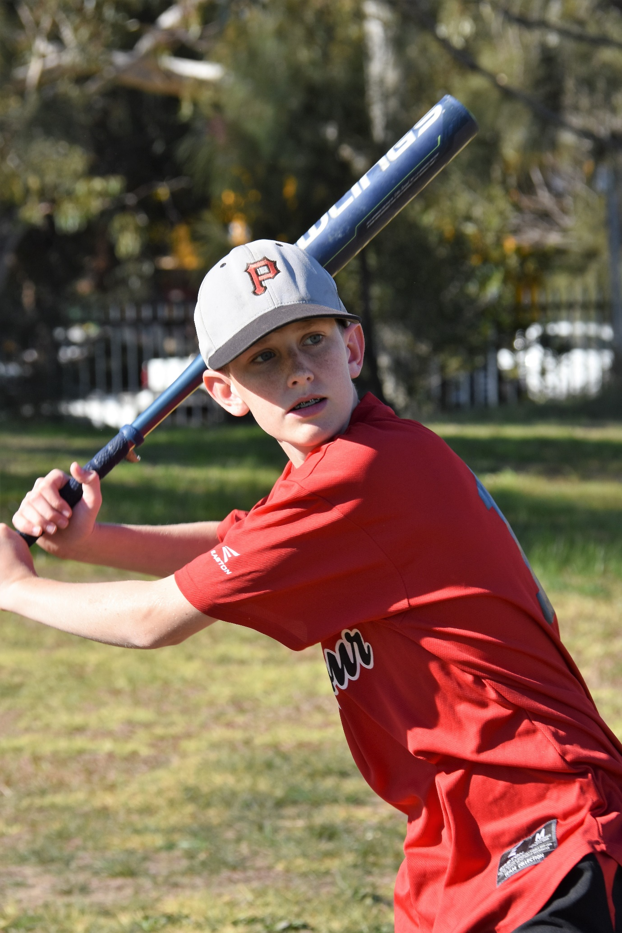

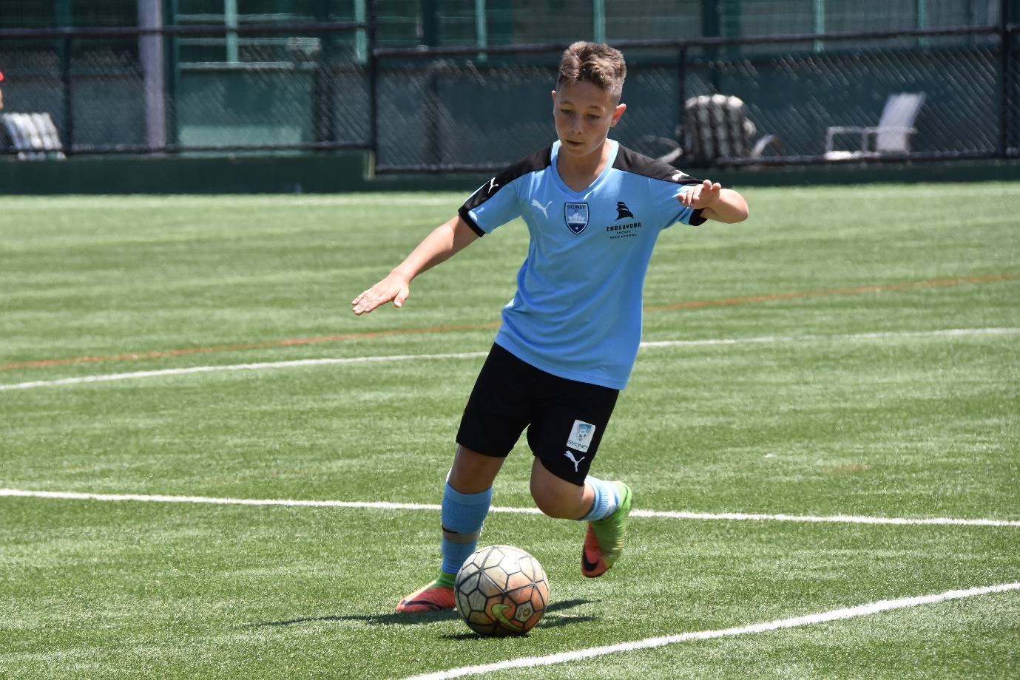
CHOICE OF SPORT

Please outline current club and grade, recent level of competition and achievements and nominate two referees who are prepared to support your application.

APPLICANT NAME __________________________________

SPORT NAME - 1st CHOICE ___________________________________

Current Club and Grade ___________________________________

Preferred Position ___________________________________

Recent Level of competition and ___________________________________
Achievements ___________________________________
___________________________________
___________________________________
___________________________________

Name and contact details of two ___________________________________
Referees ___________________________________
___________________________________
___________________________________

Additional information ___________________________________
___________________________________
___________________________________

******************************************************************************************************

SPORT NAME - 2nd CHOICE ___________________________________

Current Club and Grade ___________________________________

Preferred position ___________________________________

Recent Level of competition and ___________________________________
Achievements ___________________________________
___________________________________
___________________________________
___________________________________

Name and contact details of two ___________________________________
Referees ___________________________________
___________________________________
___________________________________

Additional information ___________________________________
___________________________________
___________________________________

